Unit I
Chapter 1.4
(Third Normal Form 3NF)
Third Normal Form
For a relation to be in Third Normal Form, it must be in Second Normal form and the following must satisfy −
- No non-prime attribute is transitively dependent on prime key attribute.
- For any non-trivial functional dependency, X → A, then either −
- X is a superkey or,
- A is prime attribute.
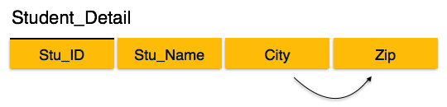
We find that in the above Student_detail relation, Stu_ID is the key and only prime key attribute. We find that City can be identified by Stu_ID as well as Zip itself. Neither Zip is a superkey nor is City a prime attribute. Additionally, Stu_ID → Zip → City, so there exists transitive dependency.
To bring this relation into third normal form, we break the relation into two relations as follows −
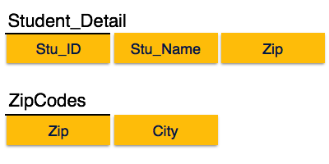
The third normal form is the nest database normalization form. Any relation is said to be in the third normal is it satisfies the below conditions:
- The relation should comply with the second normal form (2NF).
- Any non-prime attribute should not have a transitive functional dependency on the super key.
You can also define the third normal form of database normalization as the table should be in the 2NF and the functional dependency X -> Y should follow any one of the following conditions:
- X should be the superkey of the relation.
- Y should be the prime-attribute of the relation.
We shall see how the table complies with the third normal form. Consider an Employee relation having Emp_ID, Emp_Name, Emp_Zip, Emp_State, Emp_City, and Emp_District. This relation is represented as follows:
Employee
The super keys of the Employee relation are {Emp_ID}, {Emp_ID, Emp_Name}, {Emp_ID, Emp_Name, Emp_Zip}, and many others. The candidate key is {Emp_ID}. Hence, the EMP_ID is the prime attribute and all other are non-prime attributes.
You can see that the three attributes, Emp_State, Emp_City, and Emp_District, are functionally dependent on the Emp_Zip attribute. We can find the zip number using the Emp_ID attribute. Hence, Emp_Zip is dependent on Emp_ID.
The three attributes, Emp_State, Emp_City, and Emp_District, are non-prime attributes. They are indirectly dependent on the Emp_ID attribute, which breaks 3NF rules. To make the Employee relation comply with the third normal form (3NF), we need to break the table into smaller tables as below:
Employee_ID
Employee_Zip
The above two tables are in the third normal form.

Other References
- Introduction to Database Normalization (softwaretesttips.com)
- DBMS - Normalization - Tutorialspoint
- Normalization in DBMS: 1NF, 2NF, 3NF and BCNF with Examples (hackr.io)
Suggested Book References
- J. Date, “An Introduction to Database Systems”,Addison Wesley.
- Navathe,“Fundamentals of Database System”, The Benjamin / Cummings Publishing Co.

